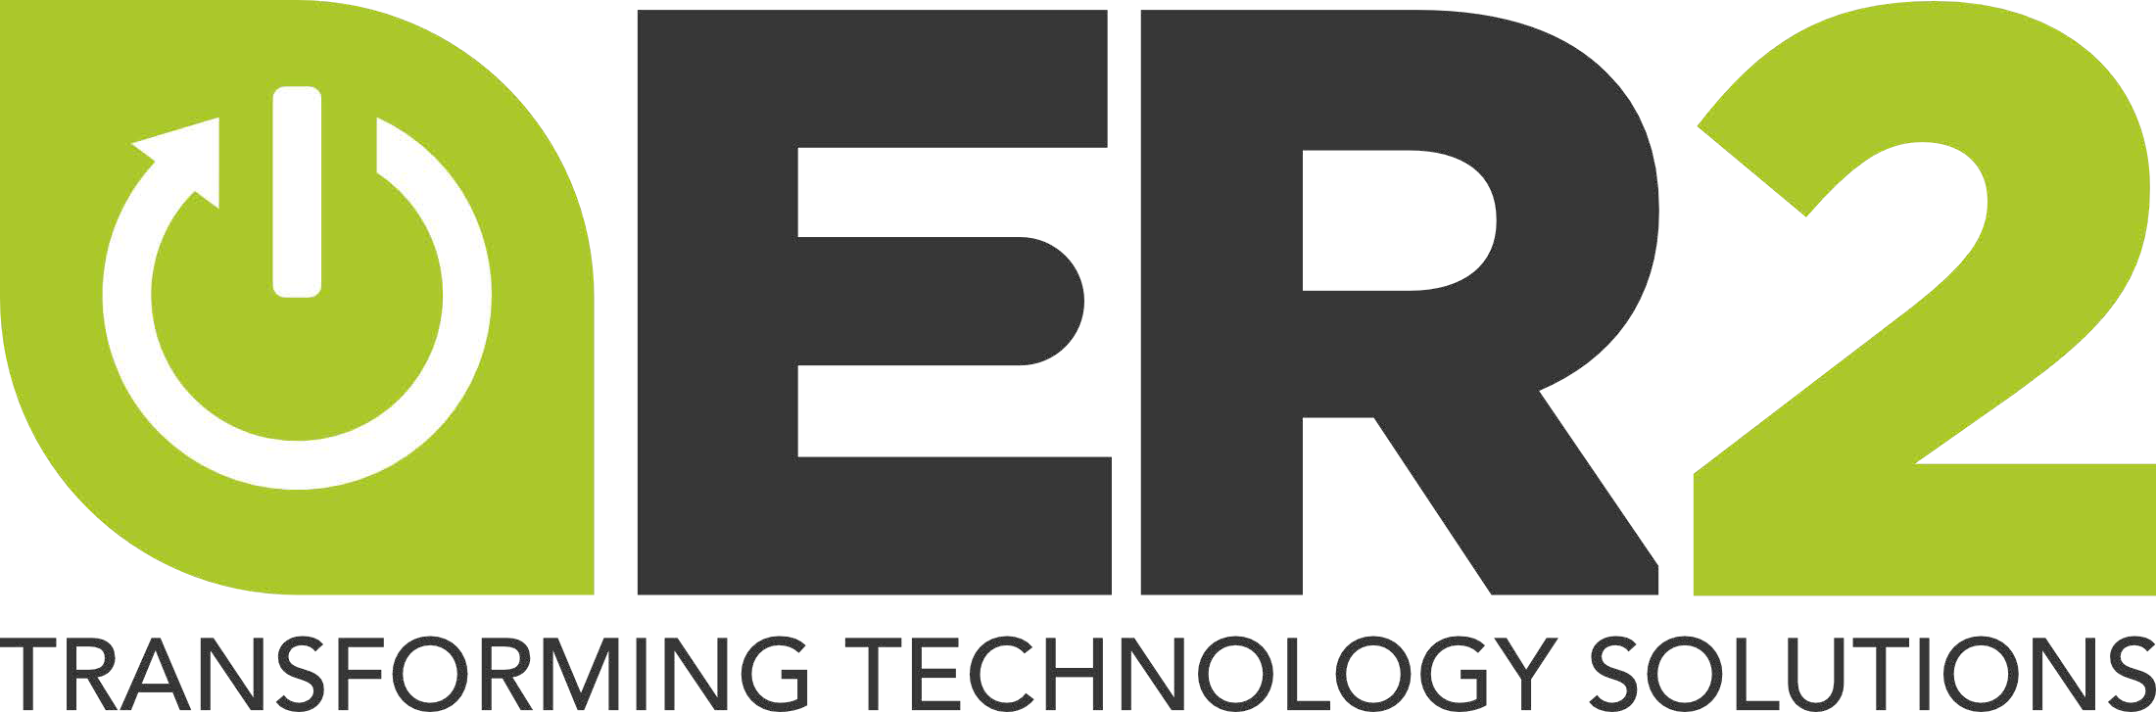

QUALITY, ENVIRONMENTAL, HEALTH & SAFETY POLICY

ER2 is committed to following the requirements of ISO 9001:2015, ISO 14001:2015, ISO 45001:2018, R2v3 and to maintain conformance to the requirements of our QEHS management system. We are equally committed to meet or exceed our customer requirements, to continually improve our processes, to prevent pollution and workplace injuries, and to maintain compliance with relevant environmental, Occupational Health and Safety and data security legislation and regulations. The goal of ER2’s operation is to have a positive impact on the environment through responsible recycling practices that includes the conservation of metals, plastic and other non-renewable resources. Consistent with these core operations, it is ER2’s overall goal to accomplish our business objectives while meeting and exceeding the environmental and health & safety expectations of our management, employees, customers, suppliers and regulators.

We will continually improve our systems while striving to minimize adverse impacts on the environment by managing and tracking through the recycling chain used and end-of-life electronic equipment, components and materials, including focus materials (FM) identified in the R2v3 Standard – with respect to both on-site activities and the selection of downstream processors/vendors - using a “reuse, recover, dispose” hierarchy of responsible management strategies.

To achieve the above statement of this QEH&S and other objectives, ER2 is committed to:

* Ensuring that these policies are appropriate to our operations and the potential quality, environmental impacts and health and safety risks;
* Complying with all relevant QEH&S compliance obligations, including legal requirements, customer and product requirements, industry guidelines and any other QEH&S commitments made by ER2;
* Striving for continual improvement;
* Protecting the environment, human health and safety, data security and social responsibility; including prevention of pollution, reducing

risks and providing safe and healthy working conditions for the prevention of injury and ill health and control occupational health and safety risks using the hierarchy of controls;

* Worker consultation and participation, and where they exist, workers' representatives, in the decision-making processes in the QEHS management system;
* Providing the framework for establishing QEH&S goals;
* Increasing customer satisfaction;
* Ensuring that this system and policies are communicated and understood by all persons working for or on behalf of ER2;
* Making the QEHS policy available to the public; and
* Ensuring that this QEHS policy is documented, implemented, reviewed and maintained, as necessary and appropriate.

We recognize that the responsibility for protection of the environment and worker health & safety are shared, requiring cooperation between employees and top management. ER2 will continually improve our environmental performance through responsible recycling practices. This will include setting goals, taking into consideration our business, financial, operational and legal requirements as well as the views of interested parties. At ER2 we will strive to be constantly Improving, acting in Humility, and living lives of Servanthood. This will enable us to live out ER2’s vision to empower uniqueness to our Clients, Team Members, Community and Environment.

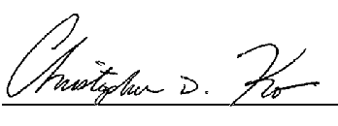

5.2.1-P QEHS Policy - 1.7.docx

Effective Date: 01-06-24 Page 1 of 1